The University of Azad Jammu and Kashmir, Muzaffarabad



Maryam Shaheen
2024-SE-30
Dtabase Systems
Engr.Awais Rathore

Department of Software Engineering
Lab#10

1. Introduction
In this lab, I worked with scalar SQL functions in MySQL. Scalar functions operate on one row at a time and return a single value for each row.
This part of the lab focuses specifically on String Functions. These functions are used to clean, format, extract, modify, and manipulate text stored in database columns.
The database used in this lab contains two tables: Customer and Product. The Customer table contains customer information such as names, emails, cities, phone numbers, joining dates, and dates of birth. The Product table contains product names and other product-related information.
The data contains some extra spaces, uppercase and lowercase names, and NULL values so that string functions can be applied to realistic data.
2. Objectives
By completing this lab, I was able to:
- Understand the purpose of scalar functions.
- Remove unnecessary spaces from text.
- Convert text into uppercase and lowercase.
- Count the number of characters in a string.
- Combine strings to create meaningful messages.
- Extract usernames and domains from email addresses.
- Extract specific characters from names.
- Mask sensitive parts of phone numbers.
- Replace spaces in product names with other characters.
- Add leading zeros to product IDs.
- Locate specific text within a string.
- Extract the first name from a customer's full name.

Database Used
The lab uses the scalar_lab database.
Two tables are used:

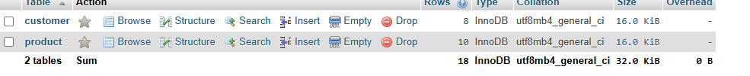

Customer Table:

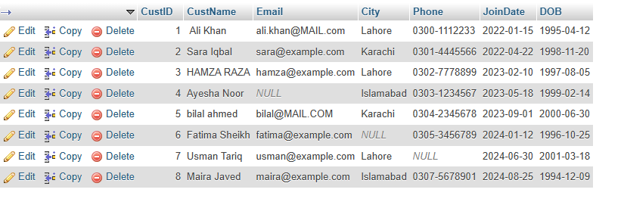
Product Table
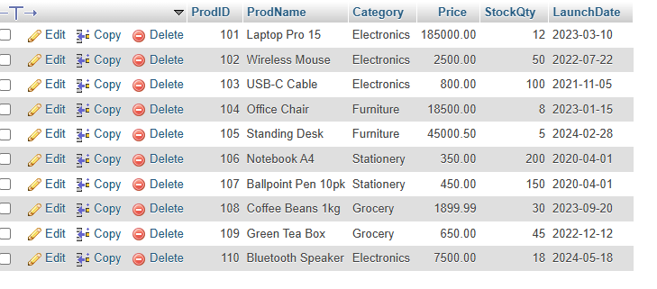

String Functions Covered
The following functions were used in this part:
TRIM()
TRIM removes leading and trailing spaces from a string.
It is useful when database values contain unnecessary spaces.
UPPER()
UPPER converts text into uppercase letters.
LOWER()
LOWER converts text into lowercase letters.
CHAR_LENGTH()
CHAR_LENGTH returns the number of characters in a string.
CONCAT()
CONCAT combines two or more strings into a single string.
SUBSTRING()
SUBSTRING extracts a specific portion of a string.
LEFT()
LEFT returns a specified number of characters from the beginning of a string.
RIGHT()
RIGHT returns a specified number of characters from the end of a string.
REPLACE()
REPLACE replaces occurrences of one piece of text with another.
LPAD()
LPAD adds characters to the left side of a string until it reaches the specified length.
LOCATE()
LOCATE finds the position of a substring within another string.

Part A
A1 — Remove leading and trailing spaces
I displayed each customer's original name together with a cleaned version of the name.
The TRIM() function was used to remove leading and trailing spaces.

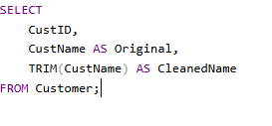
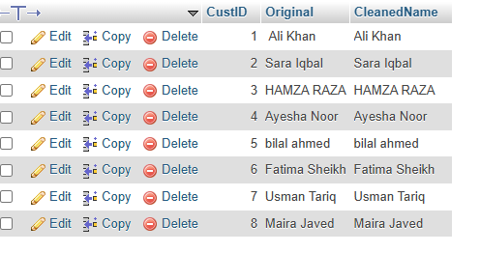
A2 — Uppercase and lowercase names
I displayed every customer's name in both uppercase and lowercase.
The UPPER() and LOWER() functions were used.

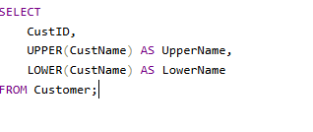
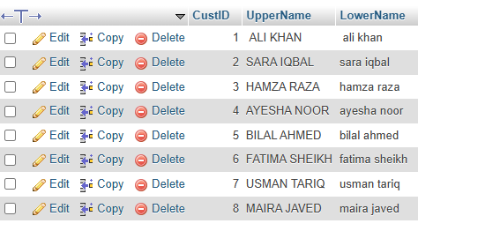

A3 — Trimmed name and number of characters
I displayed the customer's trimmed name and calculated the number of characters in it.
The CHAR_LENGTH() function was used.

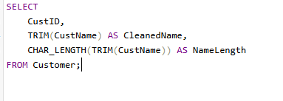
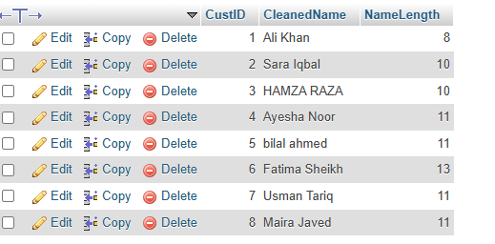

A4 — Greeting for each customer
I created a greeting message for every customer using their trimmed name.
The CONCAT() function was used to combine fixed text with the customer's name.

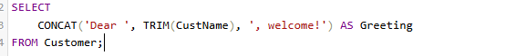
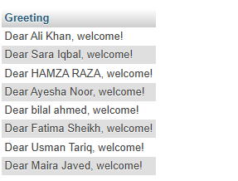
A5 — Extract username from email
For customers who had an email address, I extracted the part before the @ symbol.
The SUBSTRING() and LOCATE() functions were used.

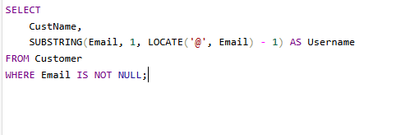
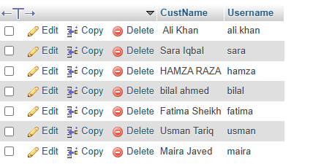
A6 — Extract email domain
For customers with an email address, I extracted everything after the @ symbol.
The SUBSTRING() and LOCATE() functions were used.

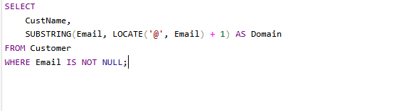
A7 — First 3 characters of customer name
I displayed the first three characters of every customer's name.
The LEFT() function was used.

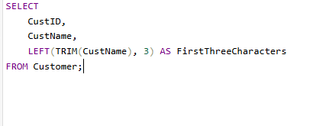
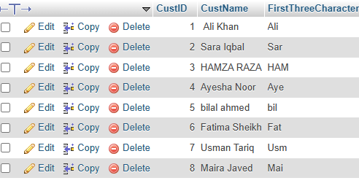
A8 — Mask phone numbers
I masked each available phone number by displaying the first four characters and replacing the remaining portion with XXX-XXXX.
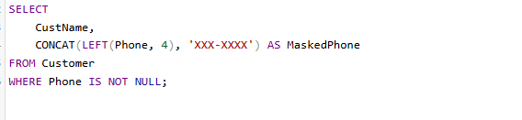
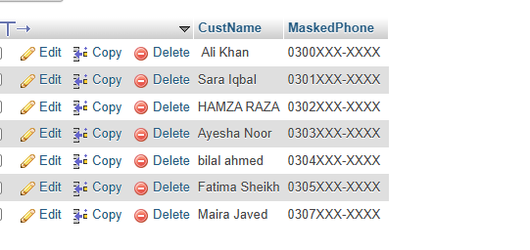

A9 — Replace spaces in product names with hyphens
I replaced spaces in product names with hyphens.
The REPLACE() function was used.

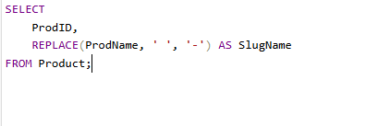
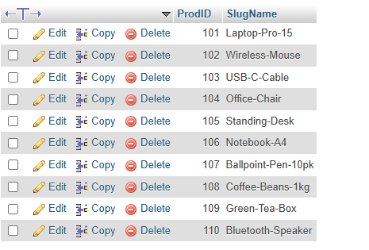
A10 — Pad Product ID with zeros
I displayed each Product ID using five digits by adding leading zeros where required.
The LPAD() function was used.

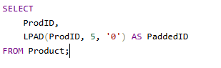
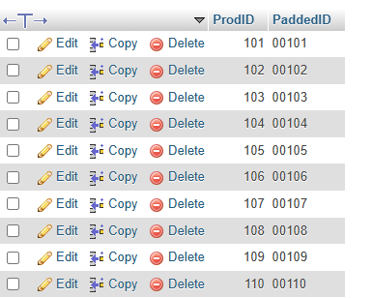
A11 — Find products containing "Pro"
I searched for product names containing the word Pro.
The LOCATE() function was used to determine the position of the text.

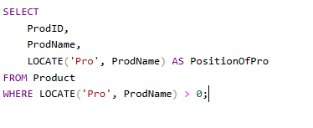
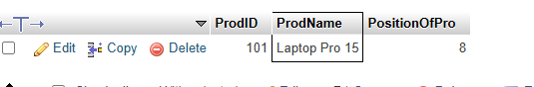

A12 — Display customer's first name
I extracted only the first name from each customer's full name.
The trimmed name and the position of the first space were used to obtain the first name.

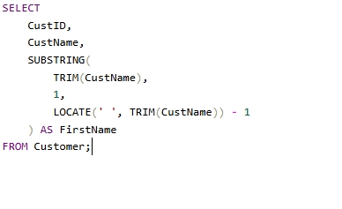
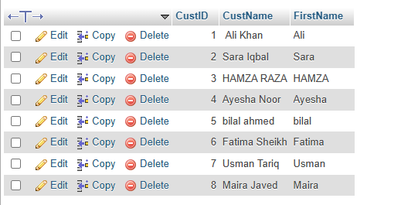

Functions Practiced
During Part A, I practiced:
- TRIM()
- UPPER()
- LOWER()
- CHAR_LENGTH()
- CONCAT()
- SUBSTRING()
- LEFT()
- RIGHT()
- REPLACE()
- LPAD()
- LOCATE()
The lab manual also explains that functions can be nested, meaning the output of one function can be used as the input of another function.
Conclusion
In this lab, I learned how to use MySQL string functions for handling text data. I performed operations such as trimming spaces, changing letter case, extracting information from emails, masking phone numbers, modifying product names, and extracting names.
These functions are useful when raw database information needs to be cleaned and presented in a more readable and organized form.

